**O.D.D Mobile**

**Obstacle Avoiding Detecting Mobile**

**Anirudh Bindal – 200383604**

**Fikayo Fakeye – 200383753**

**Shemal Thavrani - 200382943**

**Building Interactive Gadgets**

**CS – 207**

**Instructor – Trevor Tomesh**

**14th December, 2017**

**Abstract**

CS 207 – “Building Interactive gadgets” provided a project – building an Arduino run Gadget. It could be anything which is controlled by Arduino. Students were independent to choose their team members and select their project. This paper presents the technical details about the obstacle avoiding car. The project is designed to make students go through such circumstances as faced by real-life developers. This project involves designing and building of an Arduino obstacle avoiding car which could not only avoid obstacles but could also follow traffic signals. This paper will go in depth and look at the aims, design, implementation and testing of the car. It will also include a summary of all the tests carried out on the project and also all the failures, problems encountered and the overall successencountered during the course of the project.

**Table of Contents**

**Abstract………………………………………………………………………. 02**

**Table of contents……………………………………………………………..03**

1. **Introduction………………………………………………………………..04**
2. **Background………………………………………………………………..05**
3. **Procedure and Background…………………………………………….05**
   1. **Schedule…………………………………………………………….06**
   2. **Design Process…………………………………………………….07**

**Building Process……………………………………………………08**

1. **Project Working……………………………………………………………10**
   1. **Ultrasonic Sensor…………………………………………………..10**
   2. **Dual H-Bridge………………………………………………………..11**
   3. **RGB colour sensor…………………………………………………12**
2. **Milestones………………………………………………………………….14**
3. **Constraints…………………………………………………………………15**
4. **Conclusion…………………………………………………………………16**
5. **Reference………………………………………………………………….17**
6. **Introduction**

Taking a look into the world in which we are in right now one would see that everything is going into a phase in which we humans do not have to do anything anymore because everything has become a place whereby artificial intelligence has taken over everything and due to the Arduino being a printed circuit board with a microcontroller built in it. In other words, a small computer on a single integrated circuit. In modern terminology, it is similar to, but less sophisticated than, a system on a chip or Soc(Wikipedia). So due to the way in which the world is progressing and what this course was based on which was Arduino based we decided to build an Arduino project which was artificially intelligent. The project selected by the group was the Obstacle Danger Detecting Mobile also known as the O.D.D Mobile. The fundamental purpose of constructing this car was our affection towards them. Implemented add-ons to this project included the car to follow the traffic signal rules along with it to circumvent the detecting obstacle on its path.

The model of the car included four identical wheels connected by two step up motors. A dual H-bridge was connected to control the speed and motion of these motors. The Arduino gets the detection from the ultrasonic sensor and sends a signal to this H-bridge which then controls the motion of the car.

The idea was inspired from a project similar to this found on a website [1]. The car that our project was inspired from was only able to detect the obstacle. Hence, to add some originality to our project we implemented the idea of a car that also follows the traffic signal rules. For example, the car should stop when it detects a red light and then move forward to its path as the green light turns ON with the red light turning OFF at the same time. Then the novel idea was to enable the car detect and respond accordingly to traffic lights.

1. **Background**

Like any other students in the class, the team went through several websites to find our desired project. It was quite difficult to choose one of many brilliant ideas. The first design our team wanted to adopt was a “Glove controlled Robotic Hand” [2]. This was undeniably an amazing design, which could sense the flex of the palm and then have some corresponding actions. This design was dropped because of its complex design, time required and reliability.

Later we came across a design of Arduino car which detects obstacles and avoids it. This design turned out to be our final project. The concept of the car seemed to be attractive, as it defines the most basic form of AI (artificial Intelligence), Sensing and taking the most appropriate decisions. With the advent of Self driving cars, it is fascinating to understand the working of such technology. All the team members are a big fan of Tesla work. The redefined cars by Tesla in the modern world is a marvel of technology. The love for cars and the marvel work by Tesla inspired us to make this design our final project.

However, we wanted to take this design a step further, so the team came up with an idea of making the car follow traffic lights. So, now the Arduino car would not only avoid obstacles but also analyse the basic traffic signals and make moves accordingly.

**3 Procedure and methodology**

**3.1 Schedule**

The first step we took after deciding to embark on this project was to work on schedule building for complete project. To make project go in right time, it was important to make a schedule. Given below is the schedule we decided to come up with.

For each phase of the project each member was assigned a task in order

to speed up the process of the project. A member was assigned to the gathering and assembling the parts, another member was assigned to the programming aspect of the project and the remaining group member was assigned to completing the necessary documentation of the GitHub account. The plan was updated several times as a result of some of our assumptions being incorrect and problems with the delivery of most of the project parts.

**3.2 Design Process**

The design process for our project can be broken down into two parts – one involving identifying the problems of the project and other finding solutions to the problems. The designing process consists of the following steps-

* Understanding the working of the machine
* Project budget.
* Define the problems.
* Analyse the problem.
* Do Background Research.
* Gathering all required components for the build.
* Building the mobile
* Testing the design.
* Test and Redesign.

After defining and analysing the problems, we gathered information on all the required parts required for the project and that resulted into the following which we used to build the project as mentioned by the developer xxx197 on Hachester.io.

1. Arduino UNO.
2. Ultrasonic sensor-HC-SR04.
3. H-bridge motor drivers L298.
4. Car base kit (plastic frame, 2 motors, 2 wheels).
5. 2 Batteries.
6. Bread Board.
7. Jumper wires.

For out novel contribution to the project, additional components are added to the design and they are

1. RGB color sensor with IR filter.
2. RGB LED
3. Breadboard.

**3.3 Building Process**

The wheels were attached to the frame and then were connected to the motors. Bread board was placed at the front of the mobile, on top of the plastic frame. It was positioned at the front so that no other component affects the sensors. If the Ultrasonic sensor detects any component in between the obstacle, it would give undesired readings. The Dual H-bridge was screwed in the middle of breadboard and Arduino Uno.

Motor schematic:

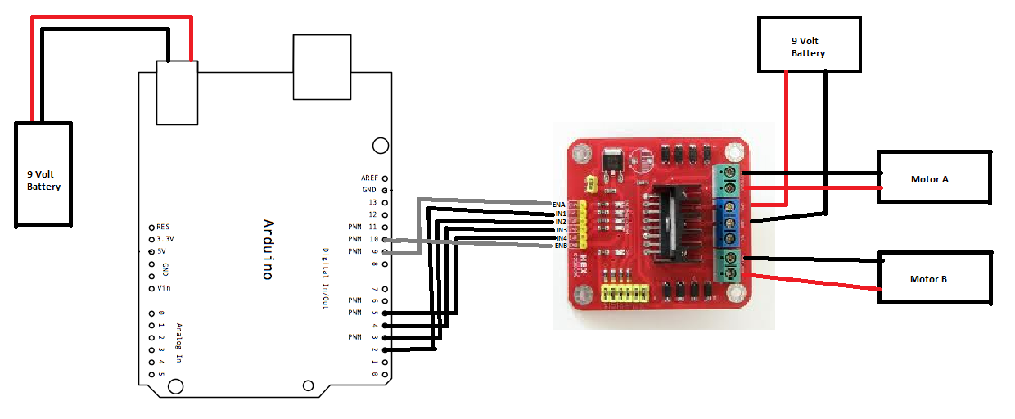

This Schematic shows the interconnections and assembly of components without our novel idea. After the arrangement of the chassis the next stage is the connecting of the motors to the H-bridge which controls the directions of the motor and also the speed. After that has been connected, the H-bridge is then connected to the Arduino through the use of jumper wires in order to communicate with the Arduino. The Ultrasonic sensor and RGB sensor is then connected to the Arduino in order to send information about the distance of the motor to the obstacle to the Arduino and also send what colour of light is being detected to the Arduino. The Arduino then takes the information provided to it and then uses it to control the H-bridge which then controls the motors.

1. **Project Working**

There are two aspects involved in the project and they are the obstacle avoiding aspect and the traffic colours sensing aspect.

* 1. The obstacle avoiding aspect is performed by the use of the ultrasonic sensor.

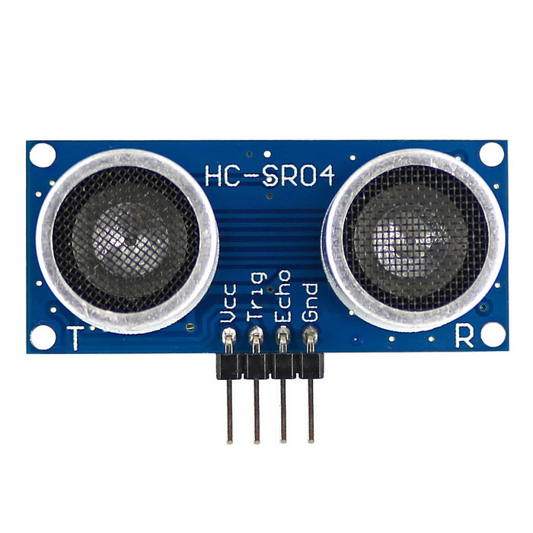

The sensor is used to detect the distance between an obstacle and the sensor. It consists of two openings the trigger opening and the echo opening. “The sensor transmits an energy in the form of an ultrasound from the trigger opening which then hits any obstacle ahead of the sensor and then times how long it takes the echo of the sound to bounces back to the echo receiver. The sensor uses this information with the speed of sound to determine the distance of the object to the motor” (Arduino-info.wikispaces.com/ultrasonic + distance+ sensor). After the distance has been calculated, a threshold value is then determined which controls how far the motor should be from the obstacle before it moves away from the obstacle. After the threshold value has been set once the sensor sends out a value less than the threshold value, the Arduino communicates with the H-bridge to control the wheels to move away from the obstacle. To use the H-bridge we have to include a library in our Arduino IDE and that is the “newping” library.

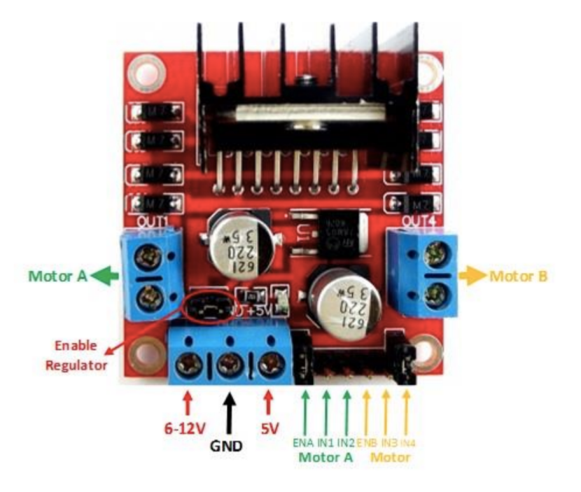 **4.2** The Dual H-Bridge helped with controlling the direction of the wheels

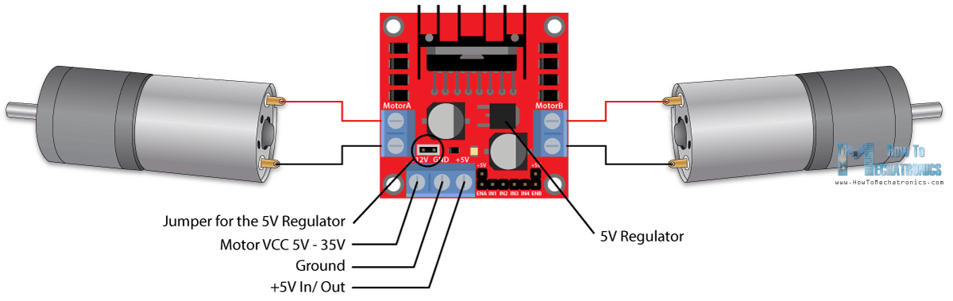

The dual H-Bridge contains four switching elements, transistors or MOSFETs, with the motor at the center forming an H-like configuration. By activating two particular switches at thee same time we can control the direction of the current flow, thus changing the rotation direction of the motor.

The L298N is a dual H-Bridge motor driver which allows speed and direction control of two DC motors at the same time. The module can drive motors between voltages between 5 and 35v. The H-Bridge has to screw blocks for motor A and B, and another terminal block which contains the ground, the VCC and a 5 volts pin which can serve as an output or input pin but due to the motor supply voltage being up to 12 volts we can enable the 5 volts regulator and use the pin as output pin.

Next are the logic control inputs. They are the Enable A and B pins and they are used to control and enable the speed. Next are the input 1 and 2 pins which are used to control the rotation direction of the motor A. We use these pins to control the rotation by setting them to either HIGH or LOW. The last are the input 3 and input 4 pins which are used to control the direction of motor B the same way input 1 and 2 are used.

After the obstacle avoiding aspect has been covered we then move on to the color sensing aspect which is done by the addition of an RGB color sensor.

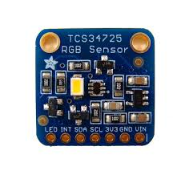**4.3** Detecting and analysing the traffic signals was done by RGB colour Sensor

RGB stands for Red, Green and Blue. So basically, what the RGB sensor does is that it senses the wavelength of these particular colors and reports back to the micro-processor. It comes with an IR (Infrared) filter. This IR filter that is integrated on the chip, gives a clear measurement of the incoming light [3]. This sensor reads the intensity of the general Red, Green and Blue spectrums of visible light while rejecting the Infrared light sources. The implement of this particular sensor in our project was to allow the car to sense the incoming light and then be able to control its motion through the above-mentioned H-bridge.

1. **Milestones**

As shown in the table above which shows our expectation’s of how the project was supposed to be completed, we were not able to stick to it due to us not being able to predict that there would be a delay in the shipping of most of the parts to us. And because of that we had to revise our goals.

1. **Constraints**

During the course of implementing our project concept to reality, we came across various drawbacks that held us back from our original idea. The most critical drawback was the late arrival of specific parts such as the RGB sensor and the Dual-H bridge. These particular parts were supposed to be delivered on 15th November but the actual delivery of the parts was altered and they arrived on 1st of December. Besides this, another drawback that occurred was after the arrival of the parts, there was need of some specific jumper wires which were tough to find at that time and the presentation date was fast approaching. So, a decision was made to solder the wires we had instead. As none of the group member had any experience with soldering, there were multiple attempts in completing that specific task. In addition to that, another drawback that held us back from completing the O.D.D Mobile was the motors not getting enough power to run the wheels properly but a simple trial and error made us realise our mistake which was us not using a 9V battery to power the motors. The Final drawback was the lack of knowledge of using a Dual-H bridge. There are supposed to be three specific connections to be made to the Dual-H bridge. Those being 5V, VCC and GNU. After acknowledgement of the specifics of these connections. The VCC connection is a type of control unit that regulates the speed of the motor and the 5V is the one that charges the battery that turns ON the motor. Overcoming this drawback was just as knowledgeable as the amount of difficulty that it caused. Due to the lack of time the RGB sensor was not implemented in the project as there was a need of presenting a working project.

1. **Conclusion**

Our aim was to make an obstacle avoiding car which would be able to obey traffic lights and so far, we achieved the task even though we had some minor setbacks along the way. Also, we had our sights on what more we could add to improve the project in the future and we actually came up with some more ideas such as including a mode in the Arduino in which the car would be able to be controlled with the use of a wireless controller.

Recommendations –

The first recommendation for this design project is that starting the project earlier will be better. The design is the most basic part of the project. Also make sure to buy or arrange the components earlier as it might take a long time to reach you. Secondly, teamwork is important. A group project is hard to be completed by only one person, it needs all the group members’ work together, and every group members have to do their jobs.

Mobile Summary –

|  |  |  |
| --- | --- | --- |
| Task number | Task | Comment |
| 1 | Detect Obstacle and take decision | Complete |
| 2 | Detect and analyse traffic light | Complete |

1. **Reference**
2. Xxx1997 (2017, Aug 27) *Obstacle Avoiding Robot Using l298d* retrieved from https://www.hackster.io/xxx1997/obstale-avoiding-robot-using-l298d-fe4f77
3. Thomas Nick (2015, Feb 16) Glove *Controlled Robotic Hand – Cheap and simple version* retrieved fromhttp://www.instructables.com/id/Glove-Controlled-Robotic-Hand-Cheap-and-Simple-Ver/
4. Retrieved from https://www.adafruit.com/product/1334